Share-it (Ideation by : Ruan Pretorius )

Introduction

Share-it will share all the BIG DEALS near you. This application will save you money and time to shop around. Big companies can add promotions on one website and it will allow you to plan your weekends shopping for less. The application will only show Sales/promotions of products in supermarkets. Daily deals that will expire if the promotions expires. Star rating with comments to allow customers to rate the supermarket and deals. Search engines for searching specific products. Log in and register for a safer application. Buttons to save you favorite supermarket and buttons to select products for your basket.

User Interface Design and Prototype

* Please see attached wireframe diagram or link <https://wireframe.cc/rFnPF3>.

Home Page Wireframe

Left hand side is the BIG DEALS and Supermarket star rating options. This will be displayed for the best customer experience and rated the highest. The middle page will show all the products for the selected supermarket with prices and star rating. Search option will be available to search specific products and you can save your favorite supermarkets on the rights hand side.

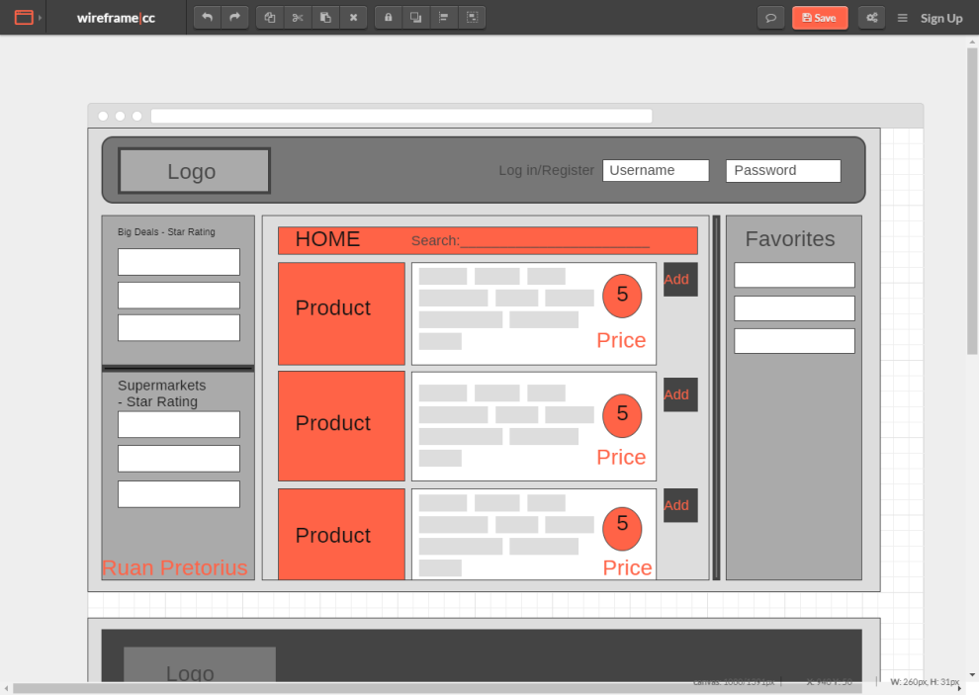You will have the option to log in or register to keep the app safe.

Basket Page Wireframe

Left hand side will show all the items you selected in a specific supermarket and it will allow you to save your list in PDF on the right hand side or you can save all the supermarkets in one PDF so you can view all your products on your phone. The total cost will show up on the right hand side so you will know how much you will be giving out over the weekend.

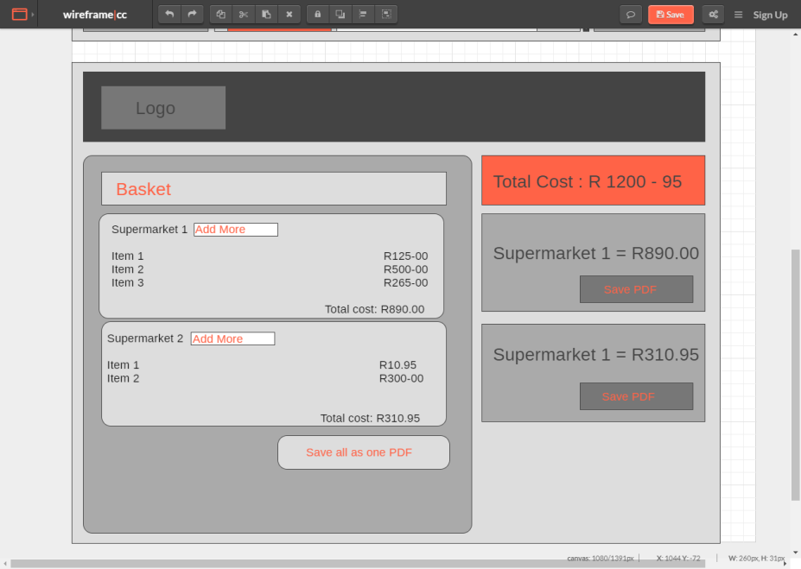

Navigation Structure

User will log in or register. They will automatically view the best deals on this app by viewing on the left side of the home page. By clicking one of the supermarkets or product they will be giving more BIG DEALS in the same category or specific supermarket. They will be given an option to save the supermarket or add the deal to the basket. By clicking add to basket and searching all the product the user require, they can easily go to basket and view the amount it will cost and save the list in PDF to view what they need to buy for the weekend.

References: I used mostly the Resources courser provided for us.

Takealot works on the same principle but only it will show BIG DEALS where you can save.

<https://www.takealot.com/deals>

<http://expo.getbootstrap.com/>

http://showcase.ionicframework.com/apps/top